**Project Design Phase-II**

**Data Flow Diagram & User Stories**

| Date | 03 October 2022 |
| --- | --- |
| Team ID | PNT2022TMID34520 |
| Project Name | Project - Signs with Smart Connectivity For Better Road Safety |
| Maximum Marks | 4 Marks |

**Data Flow Diagrams:**

A Data Flow Diagram (DFD) is a traditional visual representation of the information flows within a system. A neat and clear DFD can depict the right amount of the system requirement graphically. It shows how data enters and leaves the system, what changes the information, and where data is stored.

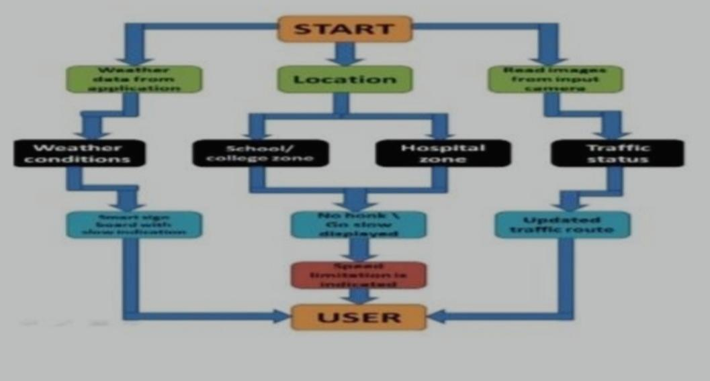

**User Stories**

Use the below template to list all the user stories for the product.

| **User Type** | **Functional Requirement (Epic)** | **User Story Number** | **User Story / Task** | **Acceptance criteria** | **Priority** | **Release** |
| --- | --- | --- | --- | --- | --- | --- |
| Customer (Mobile user) | Registration | USN-1 | As a user, I can register for the application by entering my email, password, and confirming my password. | I can access my account / dashboard | High | Sprint-1 |
|  |  | USN-2 | As a user, I will receive confirmation email once I have registered for the application | I can receive confirmation email & click confirm | High | Sprint-1 |
|  |  | USN-3 | As a user, I can register for the application through Facebook | I can register & access the dashboard with Facebook Login | Low | Sprint-2 |
|  |  | USN-4 | As a user, I can register for the application through Gmail |  | Medium | Sprint-1 |
|  | Login | USN-5 | As a user, I can log into the application by entering email & password |  | High | Sprint-1 |
|  | Dashboard |  |  |  |  |  |
| Customer (Web user) | Registration | USN-1 | As a user, I can register for the application by entering my email, password, and confirming my password | I can access my account/ dashboard | High | Spirnt-1 |
| Customer Care Executive | Toll free number | USN-1 | As an executive I can solve people queried and complaints | I can acces account information of users | Medium | Spirnt-1 |
| Administrator | Login | USN-1 | As a administration, I can log into application and web by entering my email, password and confirming my password | I can access all data in the application, I can change Or alter | High | Spirnt-1 |
|  | Update | USN-2 | As an administrator I can update the information given by the user . | I can change the data based on user given | High | Spirnt-1 |
|  | Monitor | USN-3 | As an administrator I have to monitor the details given and make use of that. | I will make the monitoring needs to check the information. | Medium | Spirnt-1 |
|  | Testing | USN-3 | As an administrator, testing is needed to check how reliable the application is. | I will ensure the testing process correctly and make it for user usage. | High | Spirnt-1 |